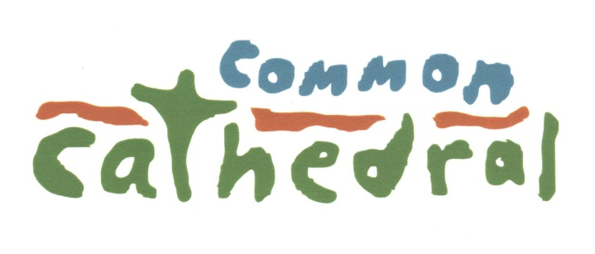
…an outdoor church for people experiencing homelessness, and their friends.

15 Newbury St, Boston, MA 02116
PHONE: 617-247-4927
Tonika@commoncathedral.org
Amanda@commoncathedral.org
CITYREACH (all sessions Grade 9 through Adult)

Academic Year 2017 - 18

___________________________________________________________________
Name of School, Church or Organization
___________________________________________________________________
Address / City / State / Zip
___________________________________________________________________
Group Leader E-mail Cell phone
___________________________________________________________________
Additional Contact E-mail Cell phone
___________________________________________________________________

Names of Participants, including adults (use additional sheet if necessary)
_________________________________ ________________________________
_________________________________ ________________________________
_________________________________ ________________________________
_________________________________ ________________________________
_________________________________ ________________________________
_________________________________ ________________________________
_________________________________ ________________________________
_________________________________ ________________________________
_________________________________ ________________________________
_________________________________ ________________________________
_________________________________ ________________________________
_________________________________ ________________________________
_________________________________ ________________________________

Total number of youth and adults __________ x $70 = _____________ enclosed
Please make checks payable to common cathedral and mail with this form to the address below at least 30 days before your session to secure your spaces for CityReach.
The first 60 registrations will be accepted. Others will be placed on a waiting list or asked to consider another session.

Please indicate below which CityReach session you wish to attend. At least one leader from your group should attend orientation. All orientations will be at 7pm via conference call.

____Nov 10-11, 2017 at Cathedral Church of St. Paul Orientation: Thursday, Oct 19, 7pm

____Dec 15-16, 2017 at Cathedral Church of St. Paul Orientation: Tuesday, Nov 21, 7pm

____Jan19-20, 2018 at Cathedral Church of St. Paul Orientation: Thursday, Dec 28, 7pm

____Feb 9-10, 2018 at Church on the Hill Orientation: Thursday, Jan 18, 7pm

____March 9-10, 2018 at Cathedral Church of St. Paul Orientation: Thursday, Feb 15, 7pm

____April 27-28, 2018 at Cathedral Church of St. Paul Orientation: Thursday, April 5, 7pm

____May 11-12, 2017 at Cathedral Church of St. Paul Orientation: Thursday, April 19, 7pm

To make sure that we are planning accordingly for all our groups we ask that any requests for refunds be sent to us 30 days prior to your group visiting.
Thank you!

Your group is NOT CONFIRMED for a session until you get an email from the office.

